Table of Contents

# View Jira Tickets Created with Xray Integration

When the tickets are created, you can see the Jira icons against the violation, and the details view in the UI.

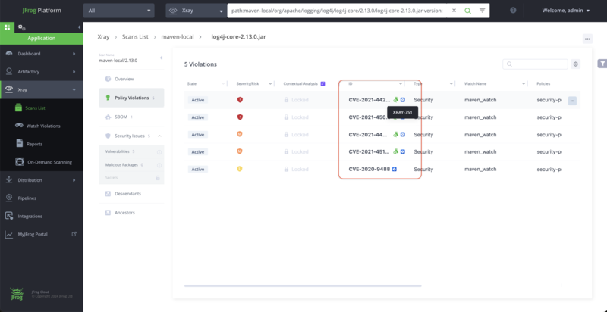

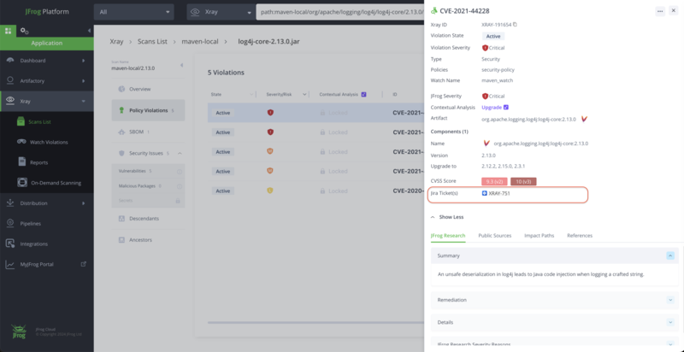

In Xray reports, the violations reports of Xray, also have the ticket ID wherever applicable.